Credit Card Onboarding
Use Case Document


 | Prepared By / Last Updated By | Reviewed by | Approved By
Name | Sivaranjani N  Sowmyaa Devi K  Sujini S.P  Shahid Ahmed F | Thirupathi S | Person 3
Role | Team Member | Trainer | Scrum Master
Signature
Date

Table of Contents
1.0 Introduction 3
1.1 Purpose & Scope of the document 3
1.2 Intended Audience 3
1.3 Use case ‘Member Registration’ 3
1.3.1 Use case attributes 3
1.3.2 Business Rules 4
1.3.3 UI Requirements 4
1.3.4 UI Field Validations 5
1.4 Use case ‘Member Status’ 5
1.4.1 Use case attributes 5
1.4.2 Business Rules 6
1.4.3 UI Requirements 6
1.4.3 UI Field Validations 6
2.0 Database Design 7
2.1 Tables Structure 7
3.0 Data Flow Diagram 8

Introduction

Purpose & Scope of the document
The purpose of this Use case document is to systematically capture requirements for the project and the system to be developed in terms of use cases. Functional use cases are captured in this document. It also serves as the input for the project scoping.

The scope of this document is limited to addressing the use cases from a member, quality, and non-functional perspective.

Intended Audience
Each member of the project team

Use case ‘Member Registration’

Use case attributes
Use Case Description:

This use case deals with the capture of member details. The ‘member’ here shall be the operator of the system and will be keying in the member details.

Scope:

- Member registration

Actors:

- Member – the operator

Trigger:

Click ‘Submit’ button in the ‘Member Registration’ page

Pre-Condition:

Member being able to access the homepage & get redirected to the ‘Member Registration’ page upon click of ‘Save’ link on the registration page.

Post Condition:

Member is in the registration page & submit details

Flow of Events:

Member at homepage → Click ‘New registration’ link → member at registration page → Click ‘save’ link → Member details are submitted and added onto the database

Primary Scenario:
A new member – is able to click ‘Save’ link and able to provide his details and get registered in the system.

Business Rules
Business rules should be defined using the following attributes: -

- When the member clicks on the form link, it should re-direct to credit card application form.
- Member needs to fill some of the basic attributes/fields as: First Name, Last Name, Age, Gender, Contact Number, UID number with questions for verification process.
- Clicking ‘Submit’ should validate the datatype constraints for each field
- Member failing to provide information on the mandatory fields be provided with an alert message – ‘Please update the highlighted mandatory field(s).’ Also, highlight the missed out field in red

UI Requirements
Here is a prototype on how the registration page should look like.

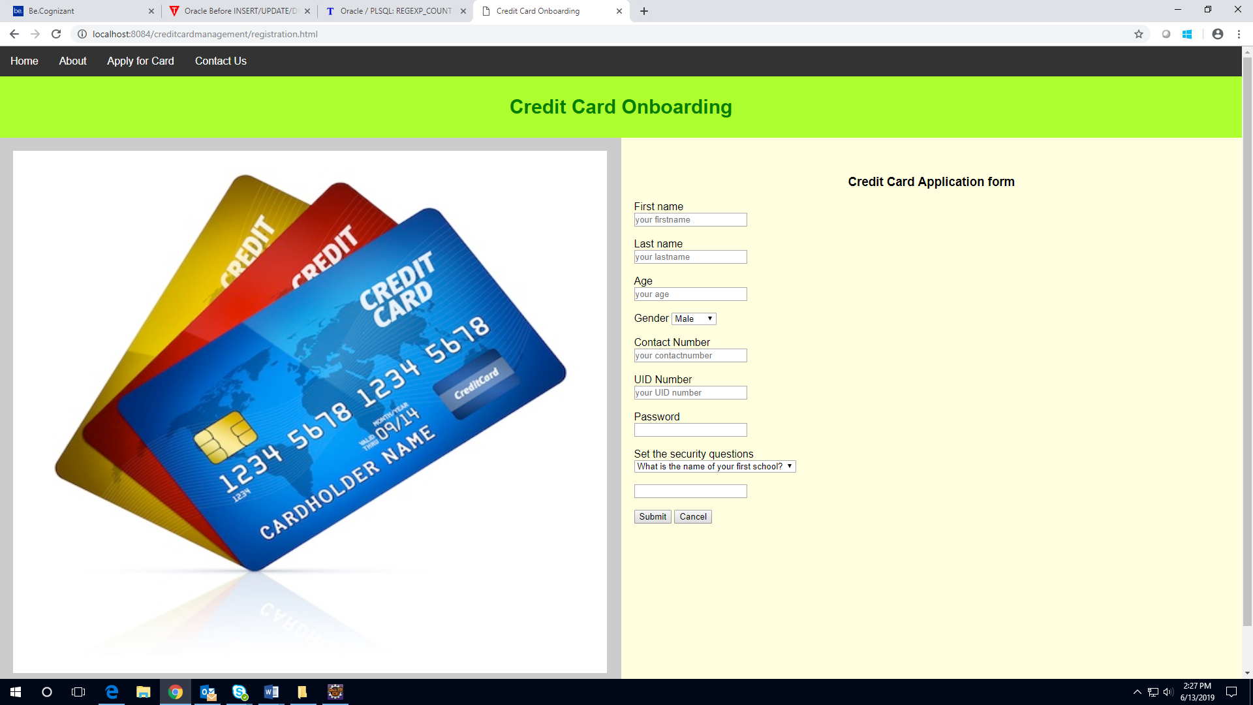

UI Field Validations
Please refer to the below requirements for field level validations:

- Some fields are mandatory (First Name, Last Name, Contact Number, UID Number, Password, Security Question, Answer)
Password should have maximum 15 alphanumeric, space & can contain special characters (ex. !,@,#,%,*,& etc.)
- The Email ID format must be checked.
- Contact Number must be of 10 digits’ length.
- Age should be 2-digit numeric value.
- First Name, Last Name should contain only alphabets.
- Gender should be chosen from the dropdown options.
- UID Number should be alphanumeric maximum.

Use case ‘Member Status’

Use case attributes
Use Case Description:

This use case deals with the status of the member. The ‘admin’ here shall be the operator of the system and will be keying in the member information into the system.

Scope:
- Member status
Actors:
Admin – the operator

Trigger:

Click ‘Login’ link, after keying in ‘Username’ & ‘Password’ field.

Pre-Condition:

Admin being able to access the admin login page

Post Condition:

Admin is in the adminhome page.

Flow of Events:

Admin at admin login page → Key in ‘Username’ & ‘Password’ field → Admin at adminhome page → Member Status to be selected by Admin whether Accepted or rejected

Primary Scenario:
The admin – is able click ‘Login’ link, after keying in ‘Username’ & ‘Password’ field and get status of the members’ updated with the existing database entry.

Alternative Scenario:
The admin – is able click ‘Login’ link, after keying in ‘Username’ & ‘Password’ field and unable to get login. The admin is presented with relevant error messages: Invalid username or password.

Business Rules
Business rules should be defined using the following attributes:
- The admin – is able click ‘Login’ link, after keying in ‘Username’ & ‘Password’ field and get status of the members’ updated with the existing database entry.

UI Requirements
Here is a prototype on how the Admin Login should look like.

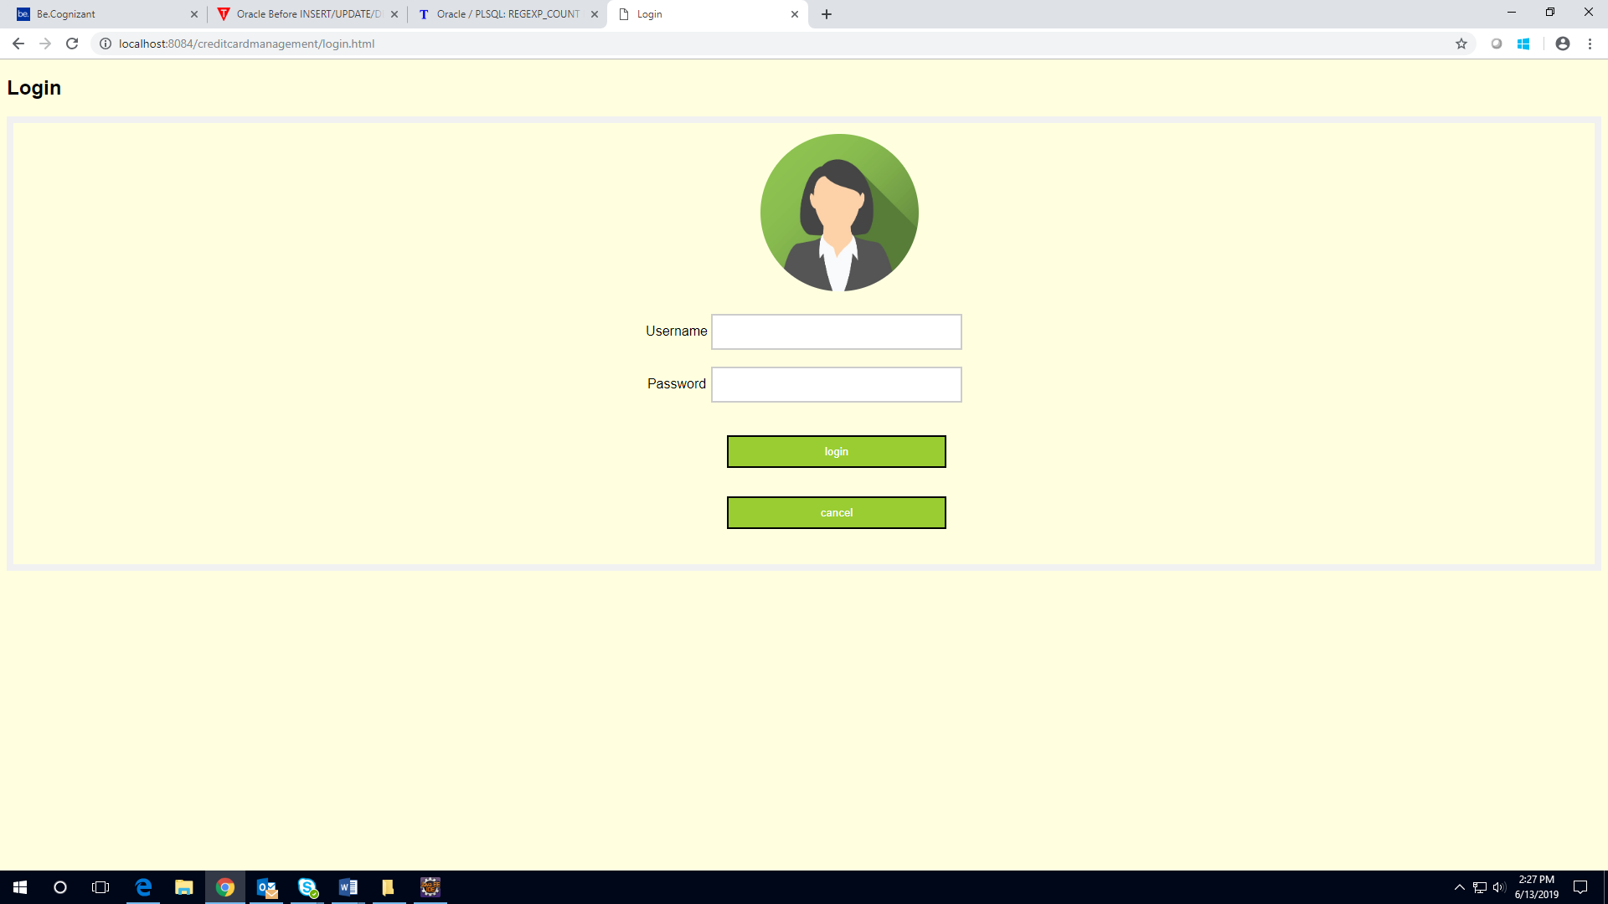

Here is a prototype of how adminlogin page will look like.



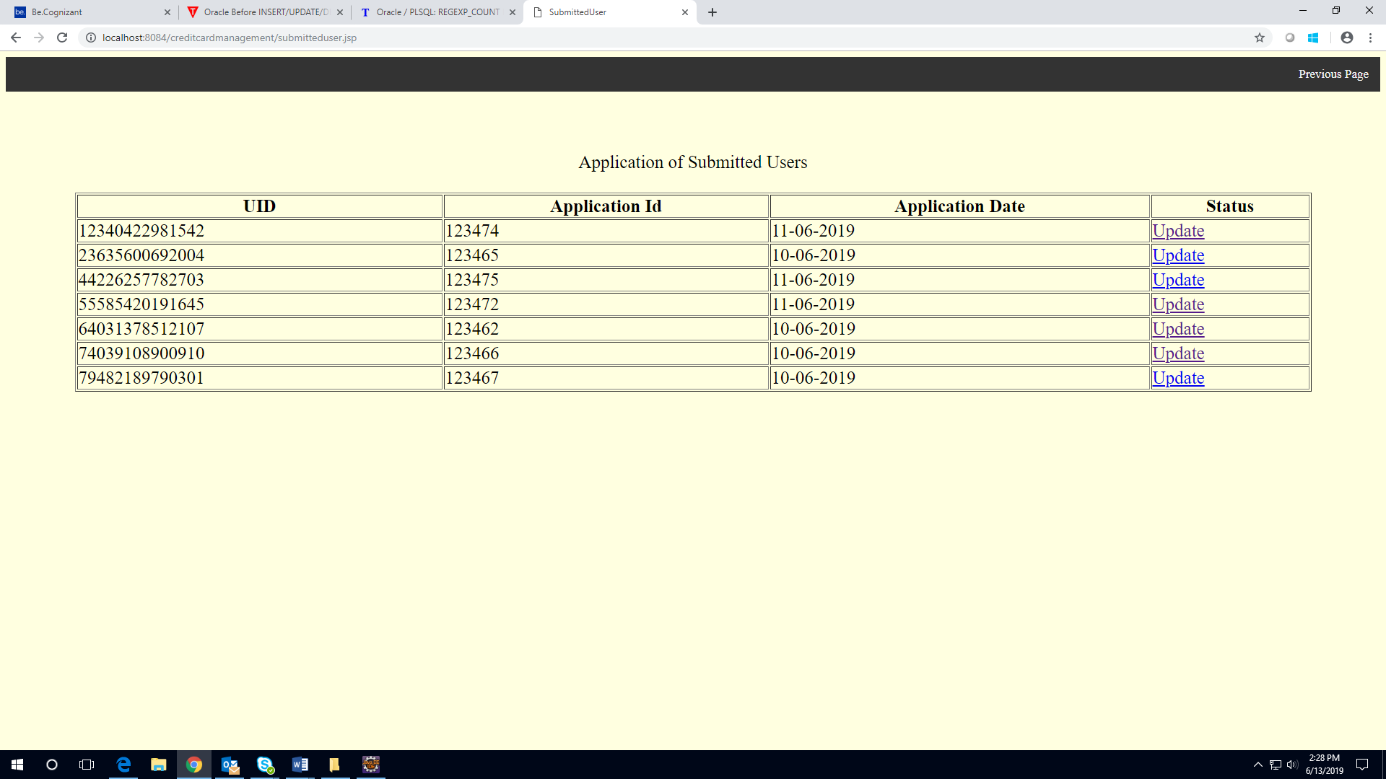

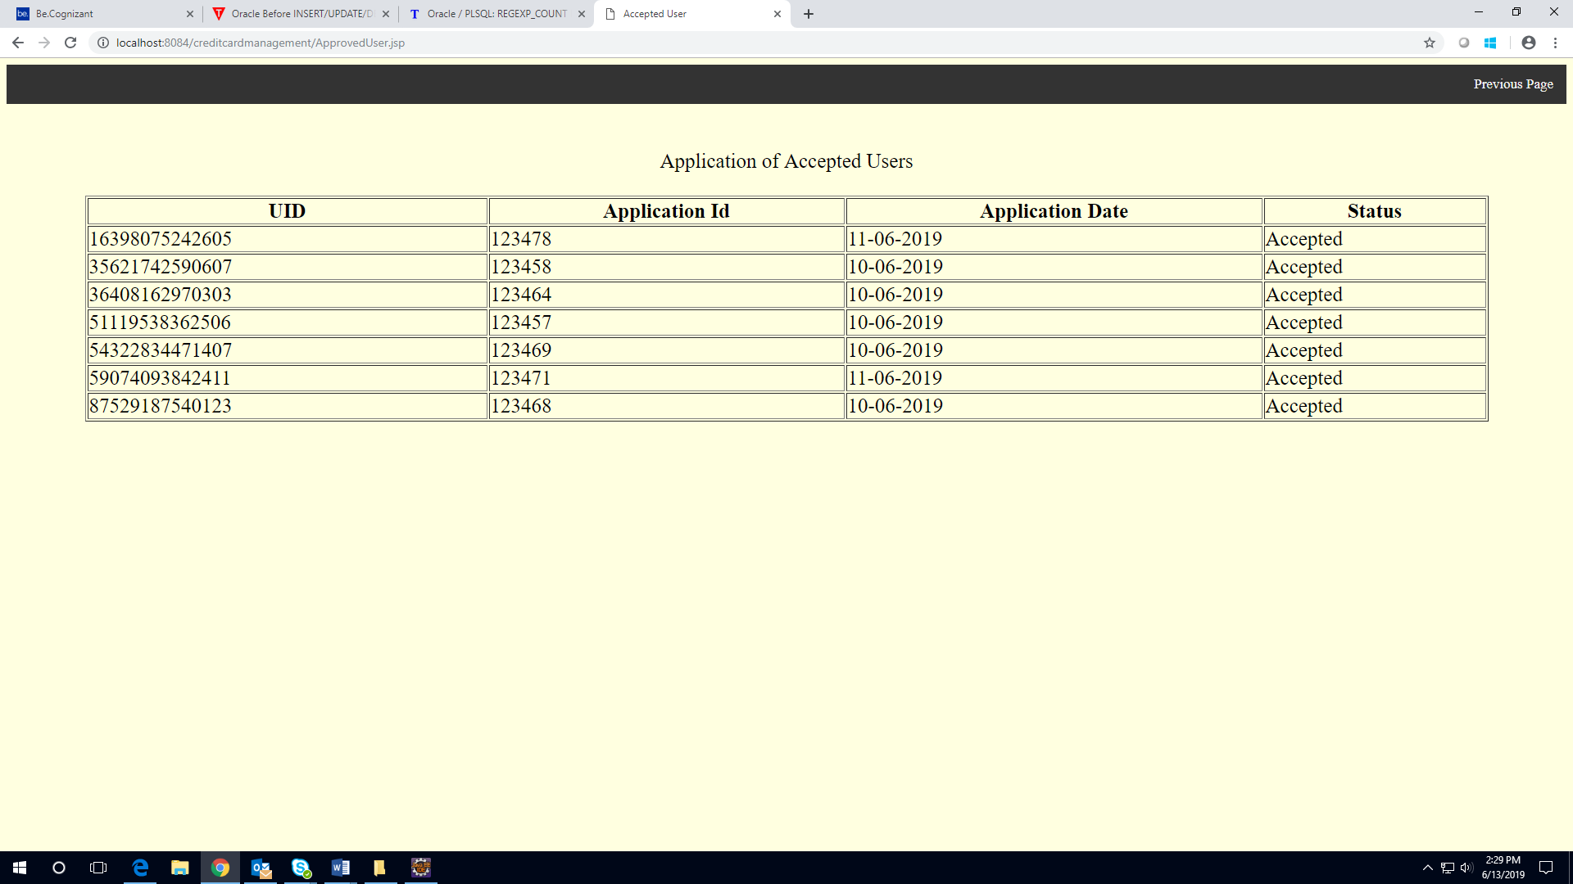

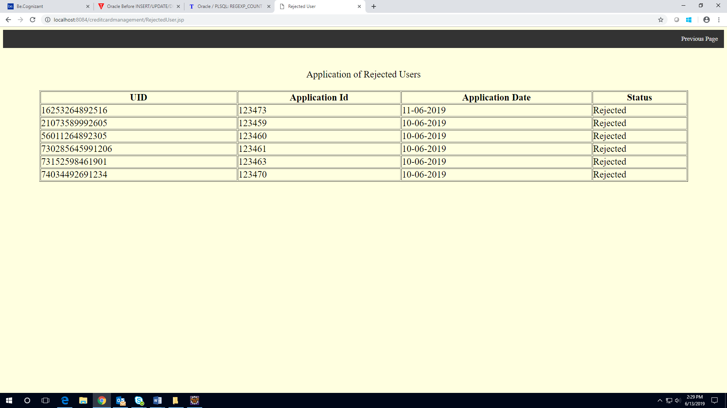

Use case ‘User Card Status’

Use case attributes
Use Case Description:

This use case deals with the status of the member. The ‘user’ here shall be the operator of the system and will be keying in the member information into the system.

Scope:

- User card status

Actors:
User – the operator

Trigger:

Click ‘Login’ link, after keying in ‘Username’ & ‘Password’ field.

Pre-Condition:

User being able to access the User login page

Post Condition:

User is in the userhome page.

Flow of Events:

User at user login page → Key in ‘Username’ & ‘Password’ field → User at userhome page → Card status is visible to the user in this page.

Primary Scenario:
The user – is able click ‘Login’ link, after keying in ‘Username’ & ‘Password’ field and get status of the members’ updated with the existing database entry.

Alternative Scenario:
The user – is able click ‘Login’ link, after keying in ‘Username’ & ‘Password’ field and unable to get login. The user is presented with relevant error messages: Invalid username or password.

Business Rules
Business rules should be defined using the following attributes:
- The user – is able click ‘Login’ link, after keying in ‘Username’ & ‘Password’ field and get status of the card’.

UI Requirements
Here is a prototype on how the User homepage should look like.

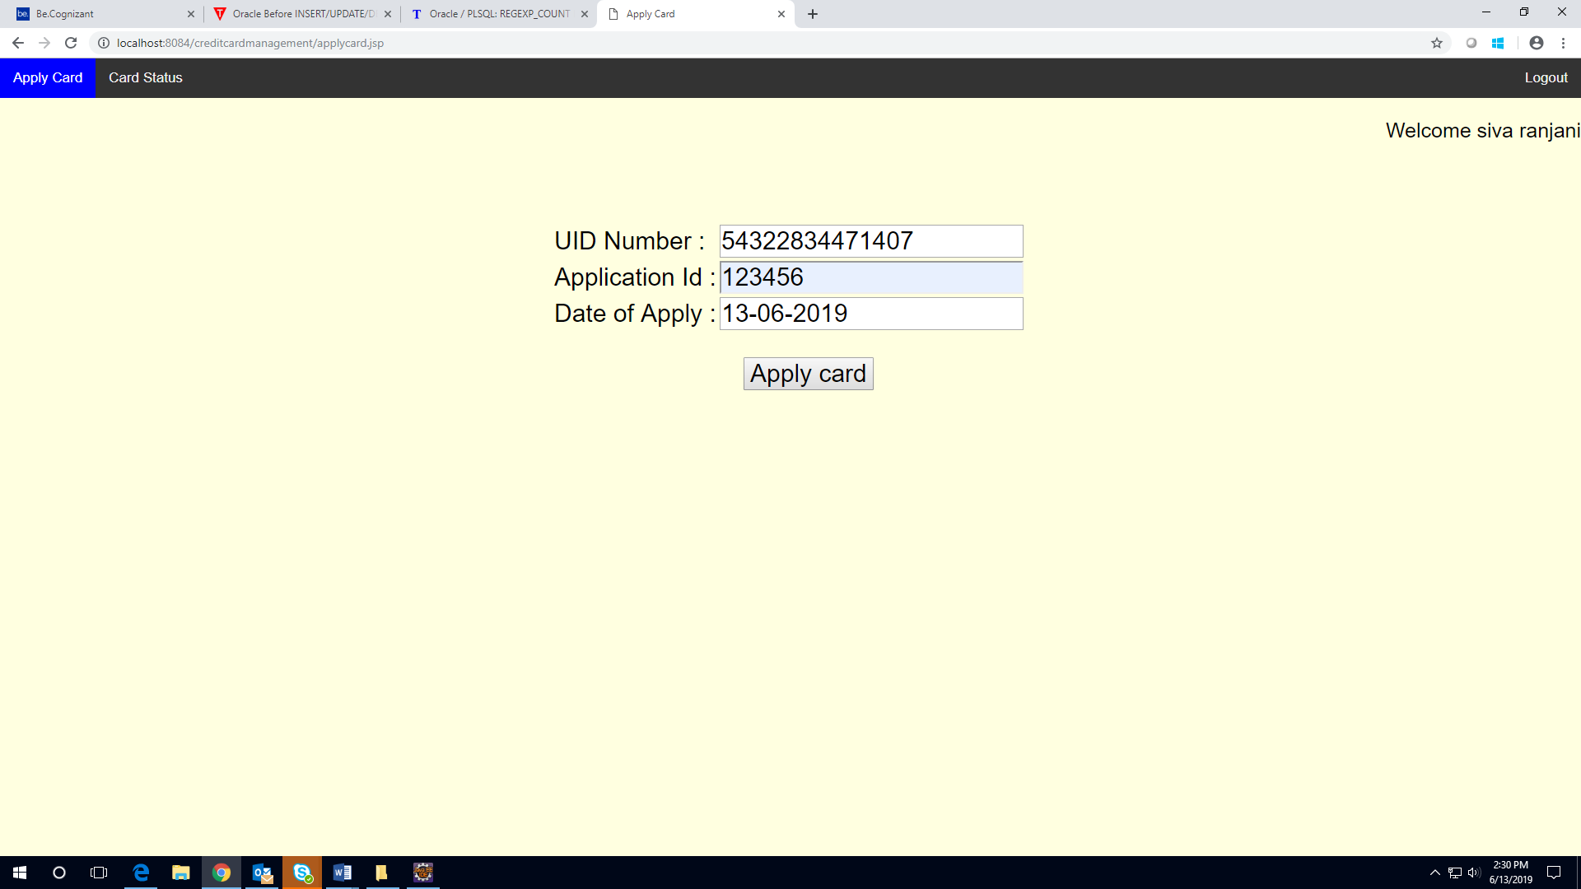

Case 1: Here is a prototype on how the User card status page should look like.

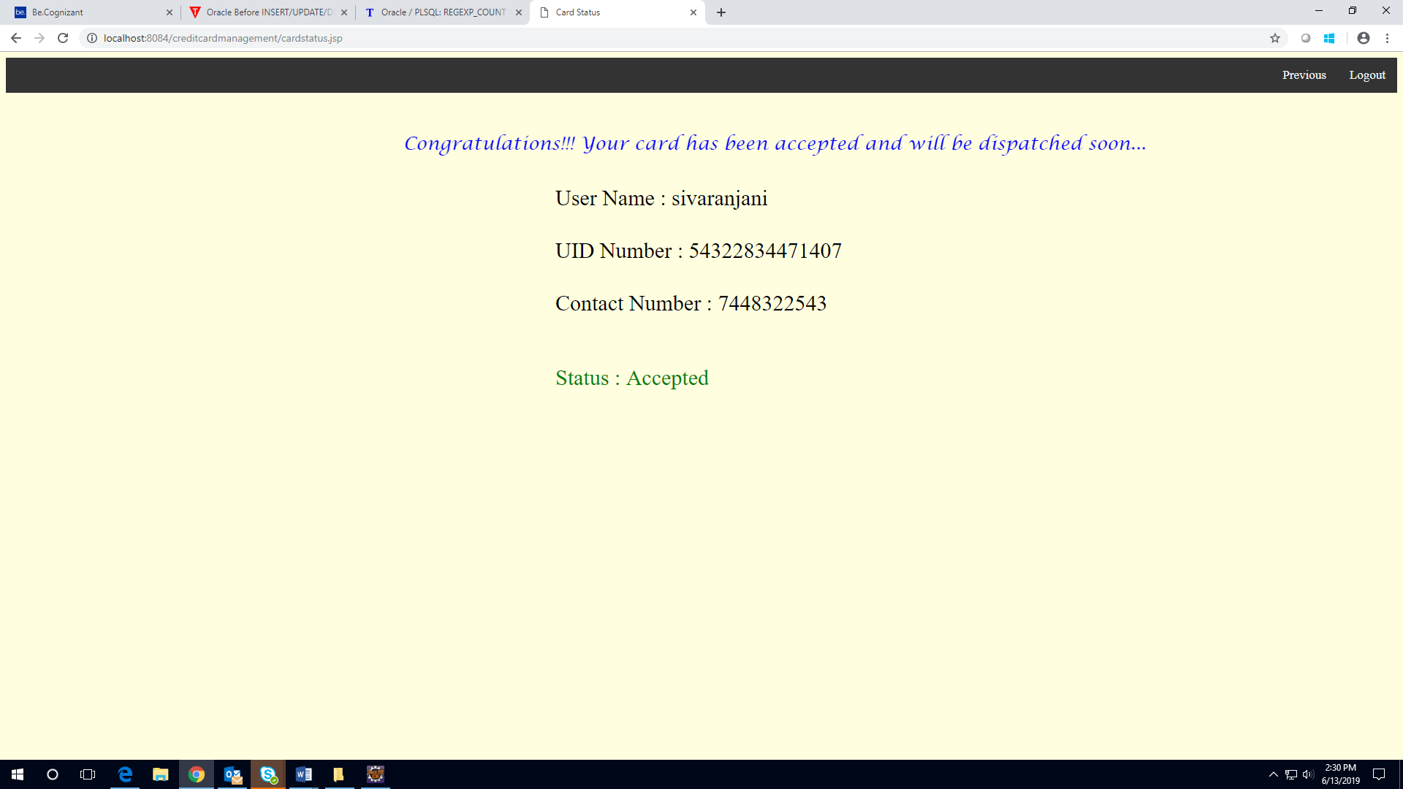

Case 2: Here is a prototype on how the User card status page should look like.

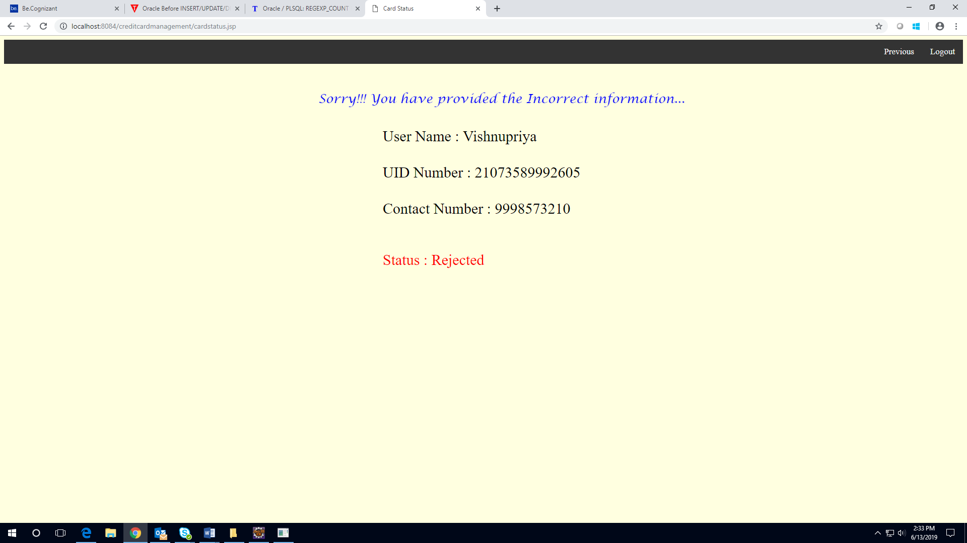

Database Design

Tables Structure
Member Details:
Column Name | Data Type | Length | Nulls
First Name | varchar | 50 | N
Last Name | varchar | 50 | N
Age | int | 2 | N
Gender | varchar | 10 | N
Contact_number | varchar | 10 | N
Verified | varchar | 10 | N
UID Number | varchar | 20 | N
Password | varchar | 15 | N
Security Question | varchar | 100 | N
Answer | Varchar | 100 | N

Application Status:
Column Name | Data Type | Length | Nulls
UID Number | varchar | 20 | N
Application ID | varchar | 20 | N
Application date | date | NA | N
Status | varchar | NA | N

Data Flow Diagram
